**SAP Module Overview**

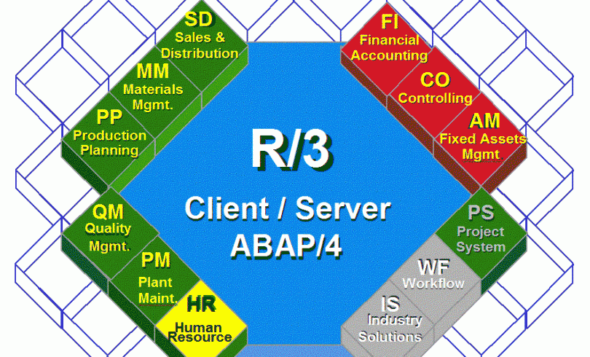

On this article you will learn about all SAP modules and a simple overview of each one. As you can see in the above picture we have 12 main modules which inside have several sub modules, you will have an overview of the main module and also links to a more detailed description of each of them. I will try to write this article in the easiest to READ and UNDERSTAND way possible to help the understanding of these basic concepts.

If you think something is missing or want something to be added to this article just leave a comment.

Now let’s go back to the above picture, as you may see the center of everything is the R/3 Client. All modules move around this “Center” which is the client which is also the string that holds all modules together:

**What is the R/3 Client?**

R/3 Client is defined as an “independent accountable business unit within an R/3 system”. A client can be a company, corporation or even a business unit. The simplest definition of an R/3 system is “*one database.*” In one R/3 system, there is only one database. To expand the definition, R/3 is considered to be all of the components attached to that one database. That’s why we have the R/3 in the middle of our SAP world. **.**

But below our R/3 Client we have the term ABAP… So now our question is:

**What is ABAP?**

**ABAP** (Advanced Business Application Programming, ABAP is an object-oriented programming language used to develop applications for the SAP R/3 system. The ABAP programming language was originally used by developers to develop the SAP R/3 platform and was also intended to be used by SAP customers to enhance SAP applications – customers can develop custom reports and interfaces with ABAP programming. The language is fairly easy to learn for programmers but it is not a tool for direct use by non-programmers. Good programming skills, including knowledge of relational database design and preferably also of object-oriented concepts, are required to create ABAP programs. SAP is also combining ABAP with JAVA. : ABAP VS JAVA.

**Currently in SAP we have twelve modules; some of them are integrated by the combination of other modules:**

[**Financial Accounting (FI):**](http://www.sap-erp.com/general/introduction-to-sap-fi-module.html) An important core module, designed for meeting all the accounting and financial needs of an organization. Within this module Financial Managers as well as other Managers within your business can review the financial position of the company in real time.

[**Controlling (CO):**](http://www.sap-erp.com/general/introduction-to-sap-co.html) Represents the company’s flow of cost and revenue, offers all the support information needed by Management for the purpose of planning, reporting and decision making. Decision making can be achieved with a high level of information reducing drastically risks. Basically It is a management instrument for organizational decisions.

[**Sales & Distribution (SD)**](http://www.sap-erp.com/general/introduction-to-sap-sd.html)**:** The SAP sales and distribution is part of the logistics module that support your customers, starting from quotations, sales order and all the way towards billing the customer.  It is tightly integrated with the MM (Material Management) and PP (Product Planning) functional modules.  It allows companies to input their customer sales price, check for open orders and forecast etc.

[**Material Management: (MM)**](http://www.sap-erp.com/general/introduction-to-sap-mm.html)**:** Is the materials management module of the SAP. This module is used for Procurement Handling and Inventory Management. Materials management (MM) is integrated with other modules such as SD (Sales & Distribution), PP (Product Planning) and QM (Quality Management). Materials management is used for procurement and inventory management.

[**Product Planning (PP):**](http://www.sap-erp.com/general/introduction-to-sap-pp.html) **T**he purpose of PP&C (Production Planning and Controlling) is to ensure that manufacturing runs effectively and efficiently and produces products as required by customers. The Production Planning module of SAP takes care of Master data needed like Bill Of Materials, Routings and Work Centers and stores it in one separate component.

[**Quality Management (QM):**](http://www.sap-erp.com/general/introduction-to-sap-qm.html) Quality management is a method for ensuring that all the activities necessary to design, develop and implement a product or service are effective and efficient with respect to the system and its performance. Quality management is the comprehensive solution that supports the company throughout the product life cycle and along the supply chain. [**.**](http://www.sap-erp.com/general/introduction-to-sap-qm.html)

[**Plant Maintenance (PM):**](http://www.sap-erp.com/general/introduction-to-sap-pm.html) oriented to cover all maintenance activities, supporting the Planning, Programming and Implementation, with emphasis on the availability of equipment, staff costs and Assurance, guaranteeing so the state of the art of database and optimization. SAP’s Plant Maintenance comprises of the following activities such as inspection, to measures and establishes the actual condition of a technical system, preventive maintenance to measures and maintain the ideal condition of a technical system, repair to measures and restore the ideal condition of a technical system and other measures that need to be taken using the maintenance organization. [**.**](http://www.sap-erp.com/general/introduction-to-sap-pm.html)

[**Human Resources (HR):**](http://www.sap-erp.com/general/introduction-to-sap-hr.html) It deals with various activities done in the human resource department of an organization, such as, Personal administration, personnel development, training and event management, payroll etc. This module enables customers to effectively manage information about the people in their organization, and to integrate that information with ”other SAP modules” and external systems. [**.**](http://www.sap-erp.com/general/introduction-to-sap-hr.html)

[**Project System (PS):**](http://www.sap-erp.com/general/introduction-to-sap-ps.html) Created to support the planning, control and monitoring of long-term, highly complex projects with defined goals .Projects are generally part of the internal processes of a company. To be able to control all tasks in project execution, you need an organizational form that is specific to the project and which is shared by all departments involved.